This you need to know about the Art Auction

- All Art work is displayed in classes around the Library.

- There will be a table set up where you can bid/ purchase artwork- this will be CASH ONLY. All you have to do is tell the ladies at the table, which piece you would like to purchase, the child’s name and classroom and of course how much you will be bidding, they will do the rest.
- You will need to pay on the night and Artwork will go home with the child the following day
- There are hot drinks and baking available for those who wish to purchase these at $2 each.
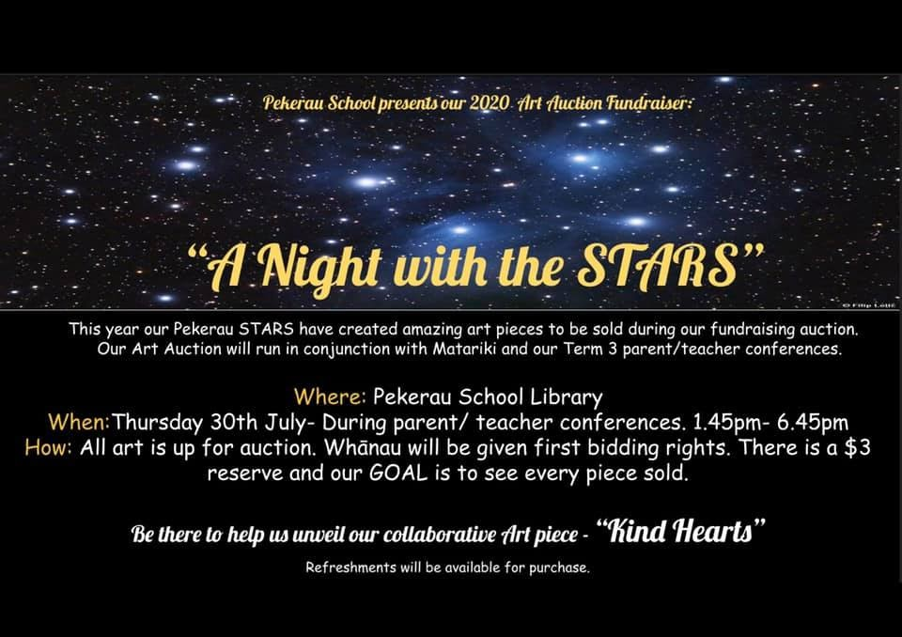
Pekerau Coffee cups are also available for $10.00 each to buy

