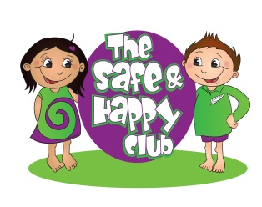
THE SAFE & HAPPY CLUB HOLIDAY PROGRAMME
The Christmas holidays are almost here and once again we are offering a fun filled programme, running from Pekerau Primary School.
We have loads planned including trips to Hamilton Zoo, Motat, LaserTag, Mini Golf, Waimarino, Horse Trekking, the Museum, pools, the cinemas and more… and numerous interesting onsite days including a visit from Young Engineers. Please see below for bookings
https://enrolmy.com/the-safe--happy-club-ltd
or email
info@safeandhappyclub.co.nz

PLEASE NOTE – FOR THOSE THAT QUALIFY, WE HAVE THE WINZ SUBSIDY AVAILABLE.

