*Unlike plastic pegs stainless steel pegs are indestructible, rust resistant and will never get mouldy or break apart****.***

***$20.00***

**ECO PRODUCTS FUNDRAISER**

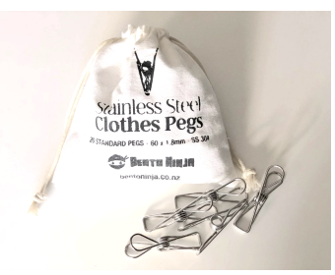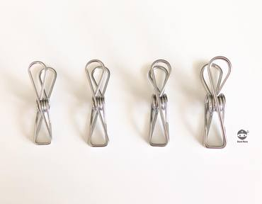

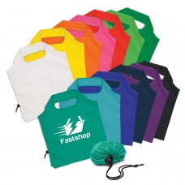

*Reusable shopping bags are the responsible choice but for large shopping trips they can be bulky to store and carry. These bags are manufactured from lightweight, strong 190T polyester. Easily folded away into a compact pouch that closes with a dome.*

**$5.00**

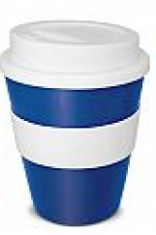

*Robust 350ml ceramic coffee cup with a large heat resistant silicone band and a secure push on silicone lid. These are presented in a black gift box and handwashing is recommended.* ***1st coffee free with purchase.* $15.00**